
COMSATS University Islamabad
Department of Computer Science

Lab Assignment 4

Name
Muhammad Abdullah
Reg No
FA24-BSE-042

Course
Information security

Course Instructor
Sir Inayatullah

Solution of Activity 1:
Step 1: Open Notepad
Step 2: Write the Shutdown Command
shutdown /s /t 60 /c "Lab Assignment 4: Controlled Shutdown Test"
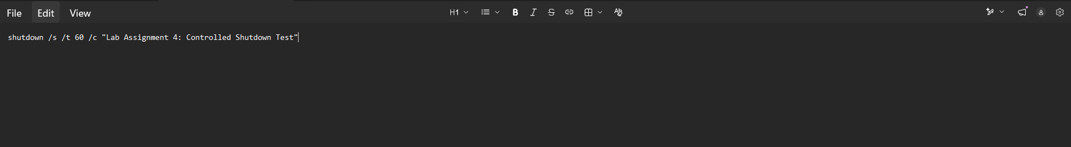
Step 3: Save the File as a Batch Script(i.e activity1.bat)
Step 4: Run the Script to Test
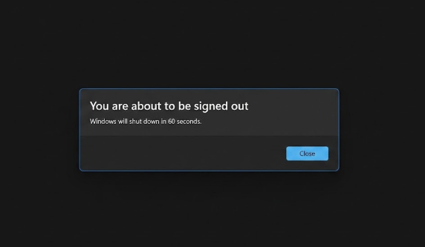
pressed the Windows Key + R, type shutdown /a to cancel shutdown.

Solution of Activity 2:
Step 1: Install Python on your system

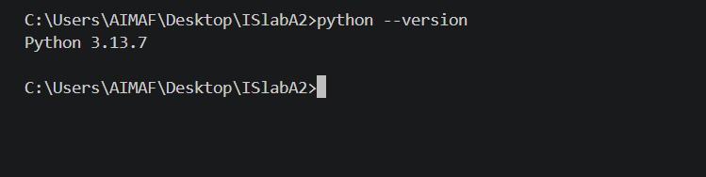
Step 2: Create a server script file
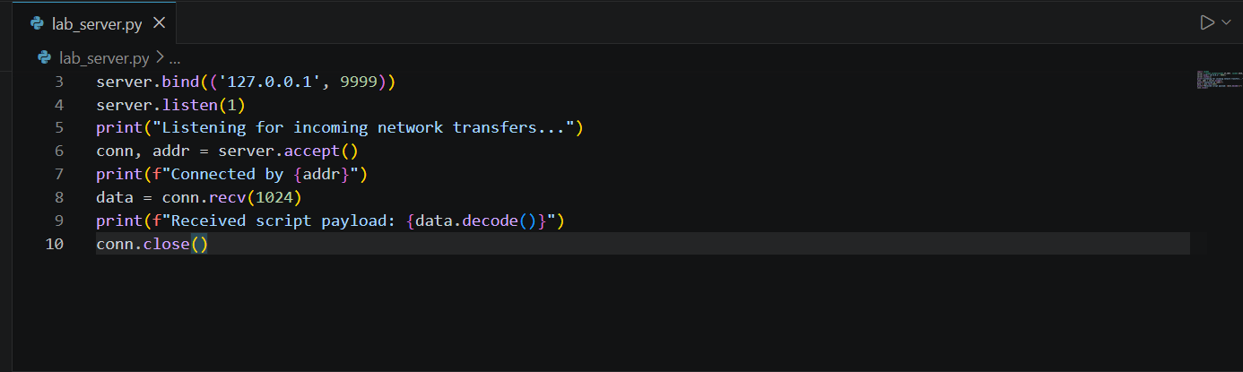
Description: This script simulates a target host by binding to your local network card and waiting for incoming data connections.

Step 3: Create a client script file

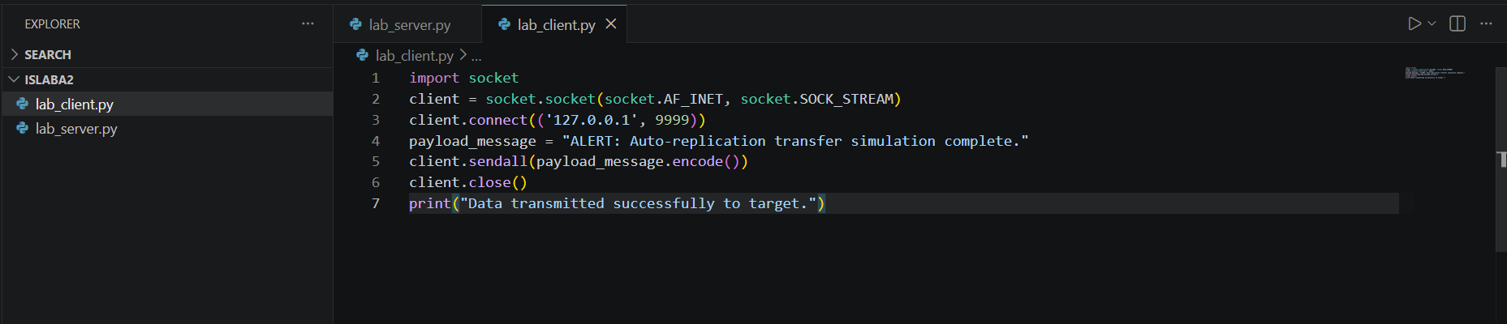
Description: This script simulates the execution side, connecting to the waiting port and pushing a data message across the network interface.
Step 4: Open two separate command prompts

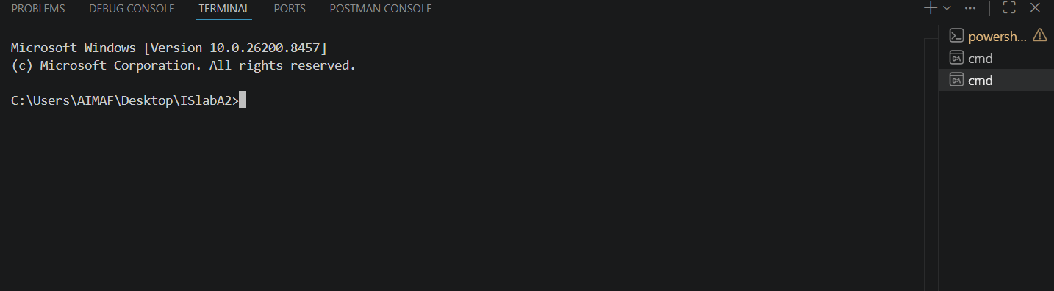
Step 5: Start the listening script first in first cmd
python lab_server.py
Description: This activates the receiving environment, opening up port 9999 to wait for incoming network socket packets.

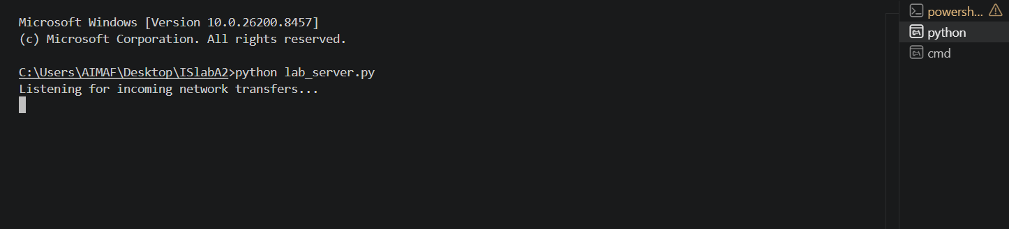
Step 6: Execute the sender script second in second cmd
python lab_client.py
Description: This launches the client script, which instantly locates the active listening port and transfers the simulation data across the loopback network adapter.
2nd cmd screenshot:

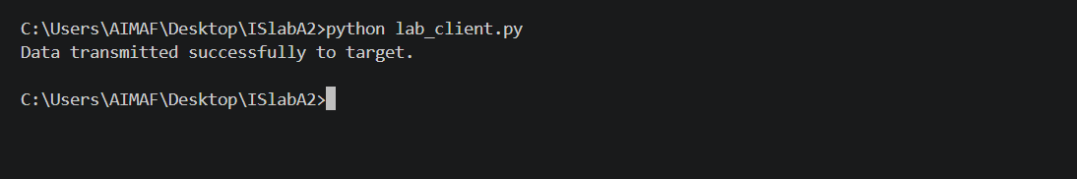
1st cmd screenshot:

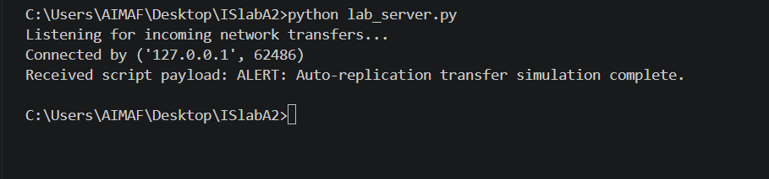

Solution of Activity 3:

Analysis of Worm Spread and Network Impact

1. Mechanism of Spread (How it Propagates)
In a real-world scenario, a network worm automates the exact socket connection process handled manually in Activity 2. Instead of hardcoding a single local IP address (127.0.0.1), a self-replicating script uses a loop structure to scan entire subnets.
- Scanning Phase: The script automatically generates a range of IP addresses (e.g., iterating through 192.168.1.1 to 192.168.1.255).
- Targeting Phase: It attempts to open TCP socket connections on specific vulnerable ports across those IPs.
- Replication Phase: When an open port is discovered, the script uses the network interface to stream its own file payload, executing it remotely to restart the cycle from that new host machine.

2. Network and System Impact (The Footprint)
When analyzing the execution of automated replication scripts, the consequences on an enterprise or lab network are rapid and severe:
- Network Congestion (Traffic Flooding): Because a worm does not wait for user input, it creates hundreds of socket connection attempts every second. This aggressively consumes local bandwidth, increases packet collision rates, and elevates network latency (high ping times).
- Resource Exhaustion: Every target system forced to process incoming connection requests or handle background socket loops experiences spikes in CPU and memory utilization. In severe cases, this leads to a Denial of Service (DoS) where legitimate network services crash.

3. Defensive Mitigation (How to Stop It)
An essential part of security analysis is documenting how to disrupt this replication behavior:
- Port Management: Closing unused logical communication ports ensures that scanners receive an immediate connection failure, halting the propagation loop before data transfer can occur.
- Firewall Segmentation: Implementing host-based or network-level firewalls prevents unauthorized cross-subnet communication, trapping self-replicating code within an isolated zone.
- Intrusion Detection Systems (IDS): Network monitoring tools like Wireshark can be paired with an IDS to flag anomalies, such as a single local host rapidly attempting to open connections across hundreds of sequential IP addresses.

Solution of Activity 4:
Step 1: Download and install Wireshark
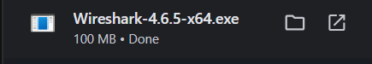
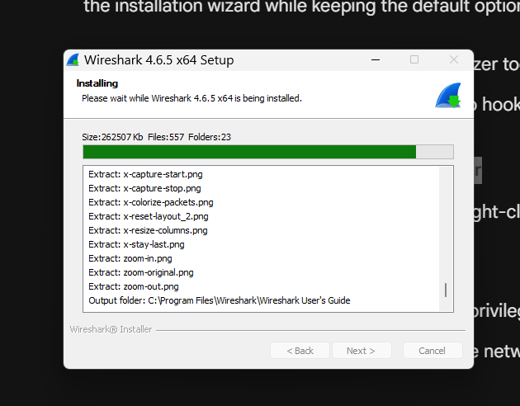
Step 2: Launch Wireshark as an Administrator
Description: Running with administrative privileges ensures Wireshark has direct permission from Windows to monitor active network interfaces.
Step 3: Select your active network interface
I did select wifi
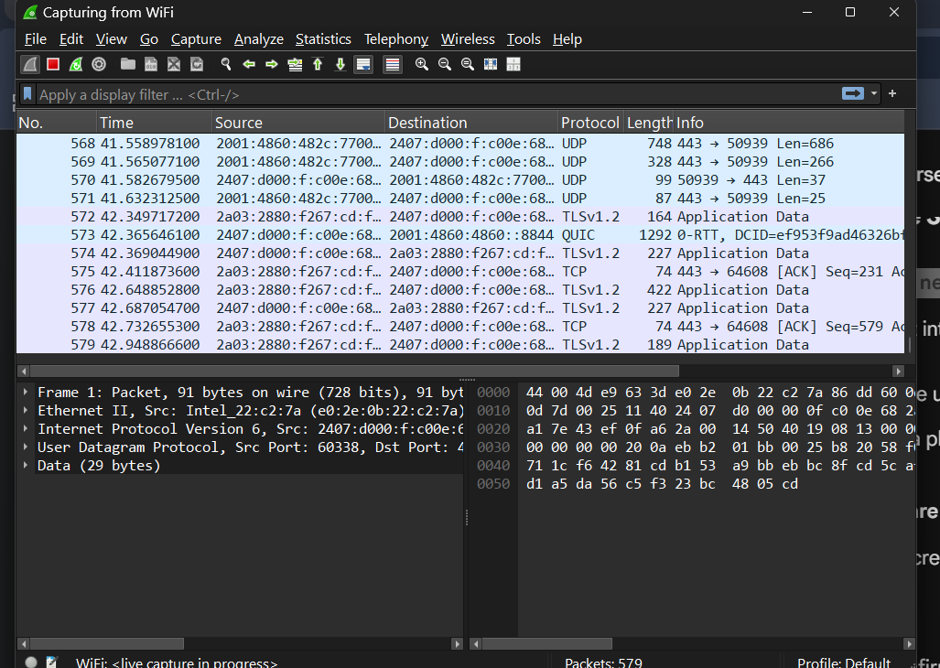
Generated some new traffic but opening fresh tab on browser:
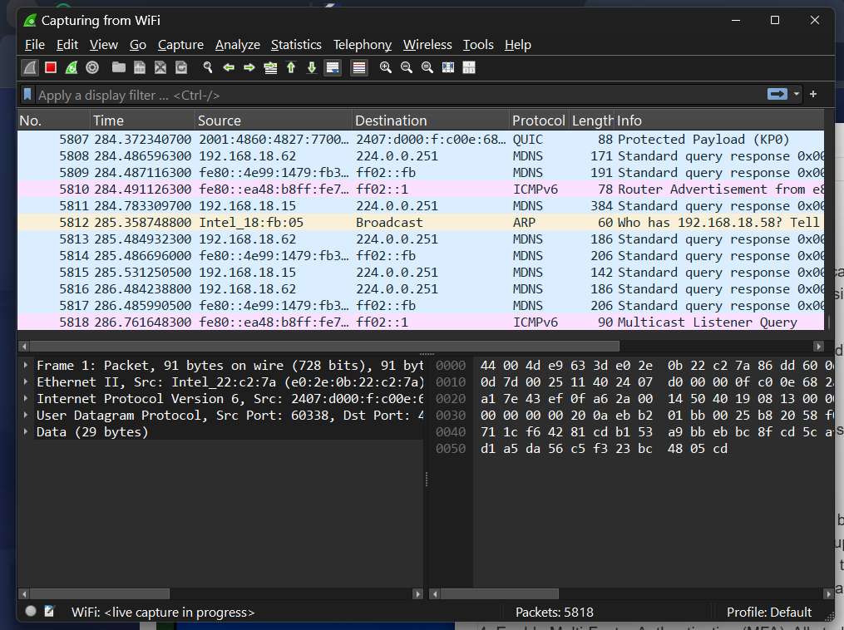
I stopped wireshark and saved captured traffic

Solution of Activity 5:
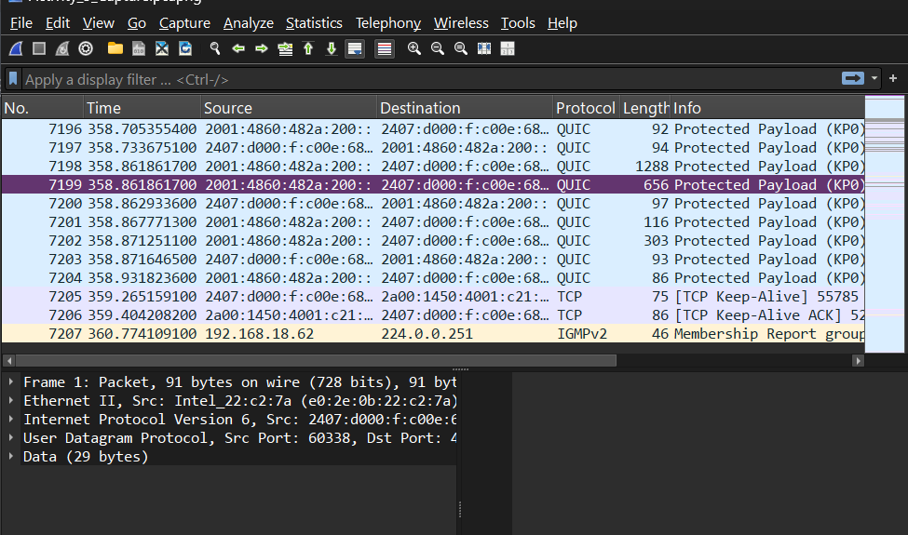

Saved the Captured traffic
